BANNER –

SILICOM ELECTRONICS PVT LTD:
The Reliable Choice for Electronic Parts

Website Content:
About Us:
"Silicom Electronics Pvt. Ltd. is a trusted and authorized distributor of high-quality Electronic Components, conveniently located in New Delhi. With nearly three decades (30 Years) of industry experience, we have consistently delivered unparalleled satisfaction and reliability to our customers throughout their manufacturing journey. Our dedicated team of trained professionals possesses extensive knowledge and expertise, allowing us to cater to a wide range of requirements while maintaining an unwavering commitment to top-tier service quality."
Our Vision:
- "We are dedicated to pioneering an era of enduring and dependable electronics within India."
- "Our foundation is built upon the principles of fostering trust through goodwill and fostering long-lasting business relationships."
- "From consumer electronics to automotive-grade components, our comprehensive product range caters to diverse needs."
- "Silicom ensures value and excellence by collaborating closely with esteemed industry principals."
Why Choose Silicom Electronics:
- "Exclusive Stocking Services: We empathize with the market's challenges and uncertainties."
- "Price Assurance: Our commitment to honouring quotations and prices remains steadfast, irrespective of market trends."
- "Transparent Communication: We prioritize clear and open communication and are committed to delivering superior quality."
- "Decades of Reputation: With a 30-year legacy, we uphold our promise of punctual delivery and competitive pricing."
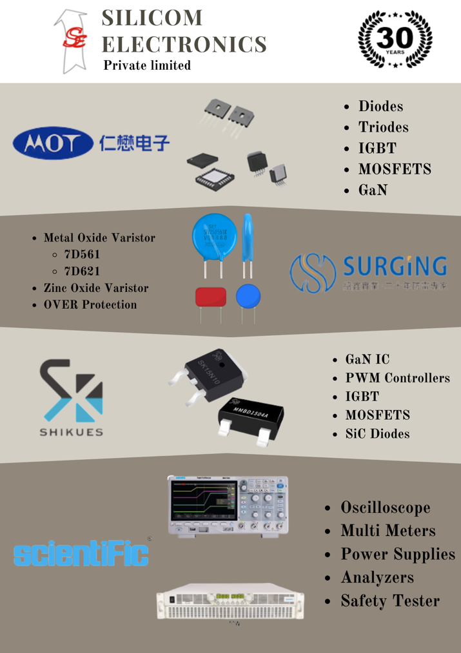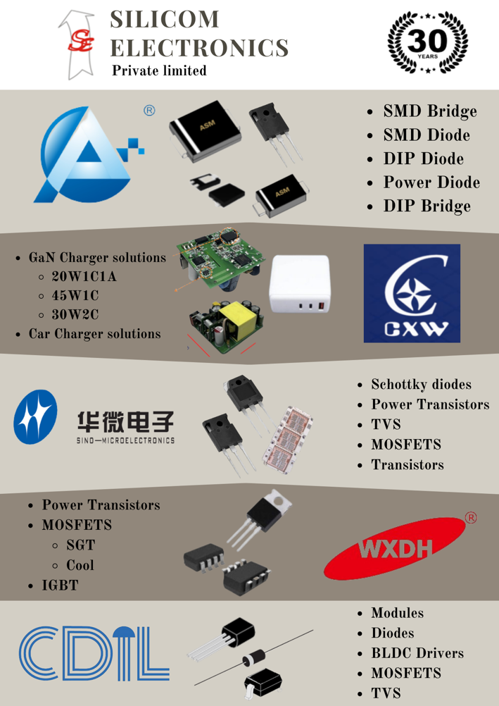

POPULAR SEGMENTS (this can be a slide show where the segment name and brands are visible) – clicking on the segment can lead to a page which talks about what parts do brands offer and small description.

    - AUTOMOTIVE - Makes with automotive certifications. Premium makes with high efficiency and high durability. Perfect recipe for long lasting electronics
      - Shikues -
      - INMARK -
      - JILIN SINO -
    - IOT – Makes that can offer slim packages to allow for best use of space in a circuit. Low current loss and increased heat dissipation.
      - ASEMI -
      - SHIKUES
      - INMARK
      - WXDH
    - LIGHTING – Industrial lighting application with parts that can handle electric surges. Highly recommended for rural application. LED drivers, precise optical sensors, and dependable power modules. Elevate your lighting designs using cutting-edge semiconductor solutions.
      - ASEMI
      - SHIKUES
    - MOBILE CHARGERS – Complete Design Solutions for GaN Chargers and CKD kits available. Competitive pricing with best quality. Extremely compact charger solutions with fast GaN charging.

      - ASEMI
      - CXW - 20W, 30W, 45W and 65W. (will include pictures)
    - BLDC - Makes trusted by OEMs and EMS manufacturers for consumer electronics. Unmatched quality at reasonable pricing. Motor drivers, high-performance hall sensors, and reliable power modules designed for seamless integration.

      - ASEMI
      - WXDH
      - JILIN SINO
    - SOLAR – Our range includes high-efficiency PV cells, intelligent microcontrollers, and precision diodes, all meticulously designed for seamless integration. Partner with us to unlock innovation in sustainable energy, backed by industry-leading semiconductor solutions. Elevate your solar panel manufacturing process today for unmatched performance and reliability.

      - WXDH
      - CDIL
      - SHIKUES
      - JILIN SINO
    - SMPS – precision voltage regulators, high-performance transformers, and dependable MOSFETs crafted for seamless integration. Upgrade your power supply designs using state-of-the-art semiconductor solutions. Step into a new era of power electronics manufacturing excellence and reliability.

      - JILIN SINO
      - SHIKUES
      - INMARK
    - EV CHARGERS – Our range encompasses high-efficiency power converters, precision current sensors, gate driver and microcontrollers.

      - SHIKUES
      - WXDH
      - INMARK
      - CDIL

- BRAND APPLICATIONS

ASEMI – Consumer electronics, Lighting, BLDC, Power
LOGO –

All their products pass SGS test, RoHS and Reach 191 criteria, etc. With continuous improvement of products quality and professional after-sales technical support, Silicom Electronics whole heartedly backs up ASEMI’s product line.
ASEMI promises to provide best quality and best price for lighting and mobile charger industry.
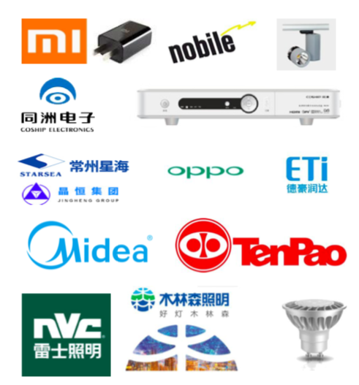

SHIKUES – Automotive Grade Components, Intelligent Sensors, LED Lighting

LOGO –
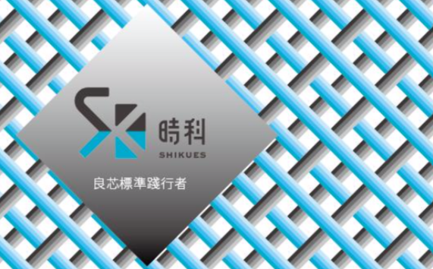
Their pioneering Taiwan based R&D centre allows for production of components with unmatched efficiency. Their goal to supply the industry with good quality and durable electronics lines up with Silicom Electronics seamlessly.

- Taiwanese product line covers more than 30 categories and 4000 items, including Schottky Diodes, ESD, Rectifier Diodes, Bridge Rectifiers, MOSFETs

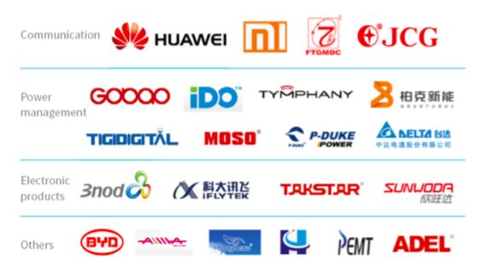

CDIL – BLDC, SOLAR PANELS,

LOGO -


With 50 years of semiconductor manufacturing experience, strict standards of quality. CDIL today is an Indian brand that is recognized globally.

JILIN SINO – 5G Base station, Switch mode power supply, Battery management systems, Automotive.
LOGO –

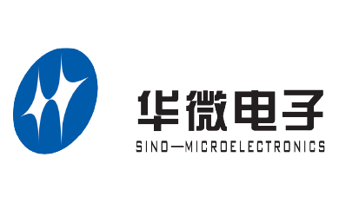

Leading Enterprise of Chinese Power Semiconductor Device Industry:
- National Enterprise Technology Centre
- National Postdoctoral Research Station National Innovative Enterprise
- Leading enterprise on Application Plan Manufacturing Champion Cultivation Enterprise
- CNAS Lab

Jilin-Sino Microelectronics values Comprehensive quality management system with more than 6 million chips and 2.4 billion pcs package resource

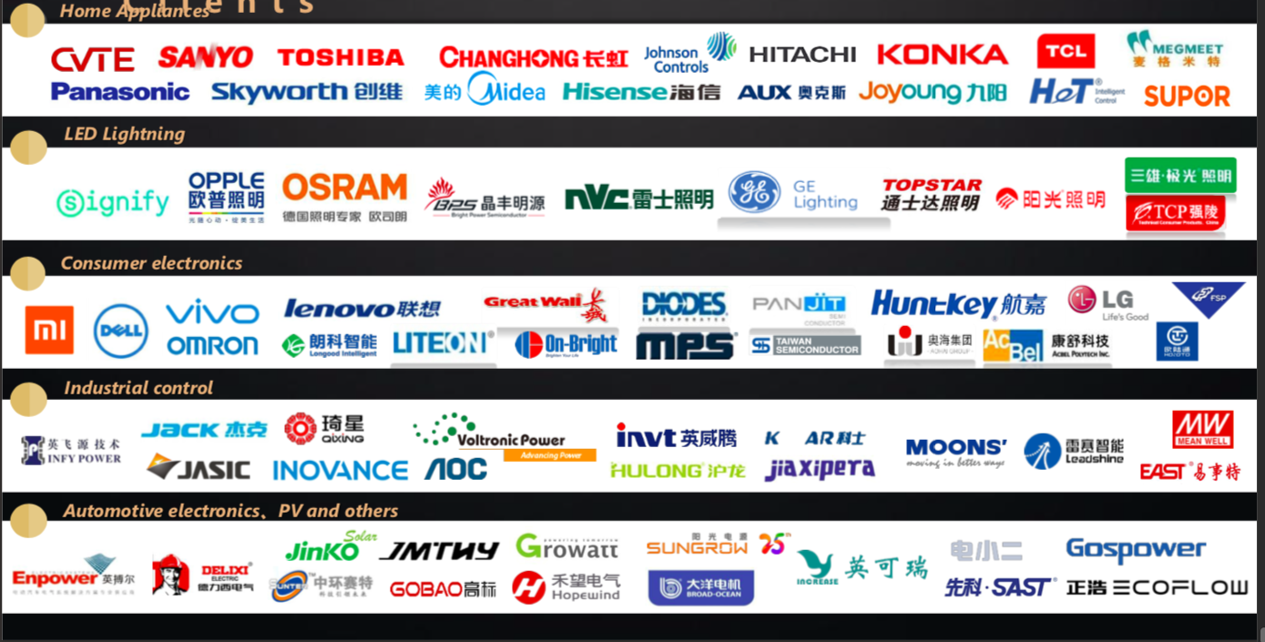

INMARK ELECTRONICS – Medical Electronics, Industrial Control, Photovoltaic Power, Mobile Communications.
LOGO –


It is a well-known high-tech enterprise in semiconductor packaging and testing in China, and is committed to providing high-quality semiconductor components for global electronic manufacturing enterprises.

- it takes the lead in deploying the third generation of nitride semiconductor materials to help the 5G era. At the same time, adhere to independent research and development and manufacturing, solve the bottleneck technology

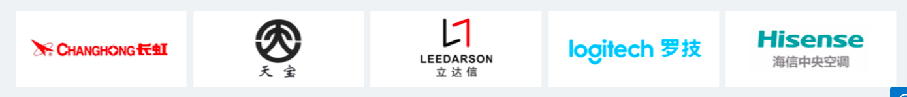
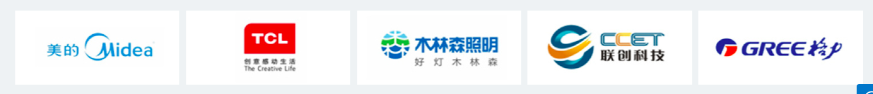

SURGING – Over voltage protection products

ShenZhen Shaoxin offers industrial quality SURGING MOV to keep your electronics safe and protected. focuses on R&D, manufacturing and selling of the over-voltage and over-current protection products. 8/20us Sparks can sustain hit 40 times

LOGO –


WXDH – Intelligent control semiconductors – IC, MOSFETS

LOGO –


Their products won the title of Well-known Trademark of Wuxi and Famous Trademark of Jiangsu Province. Wuxi Roum Semiconductor Technology has obtained several utility patents and invention patents and applied for nearly one hundred invention and utility model patents. Wuxi Roum Semiconductor Technology Co. Ltd. is always committed to enhancing product quality and keeping up with the internationally advanced level in the choice of packaging, testing equipment, packaging process and materials.
is focused on supplying of intelligent control semiconductor technology, products and system solutions

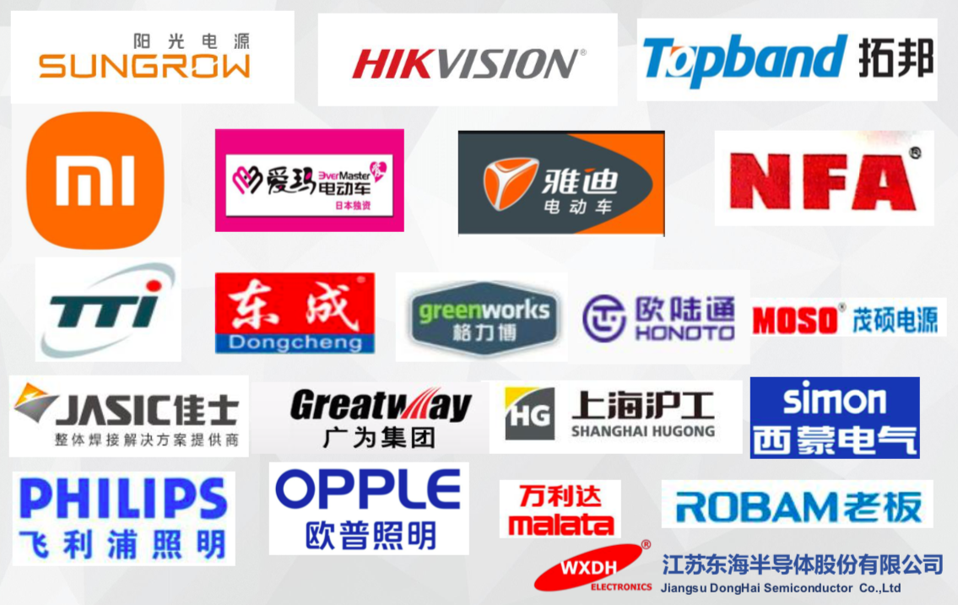

- ENQUIRY
  - Please add it as pop up on the screen.

- CONTACT

Website recommendations
https://ikio.in

https://www.srelectro.in/industrial-electronics.html

https://www.solvay.com/en/solutions-market/electronics/semiconductors/applications

https://www.spiengineers.com/

